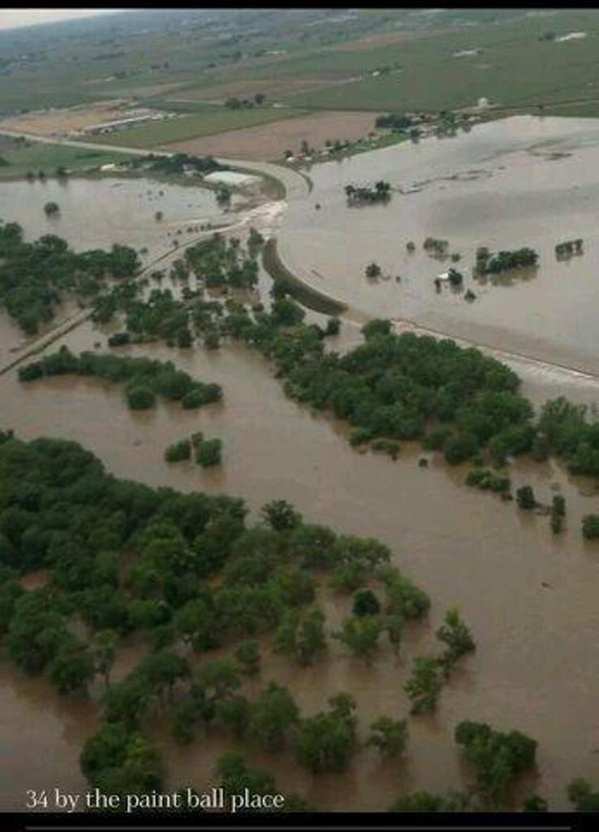
- FUND RAISER – Tommy and Nicole Meyer Family

- DONATIONS ACCEPTED
  - A LIST FROM THE FAMILY OF NEEDED ITEMS IS ATTACHED TO THIS E-MAIL
  - ALSO, monetary donations such as, cash or check or money orders made out to:
“TOMMY AND NICOLE MEYER FLOOD FUND”
Checks can also be sent c/o Carleton & DeJong, LLC at
1580 Lincoln, Suite 1200, Denver, CO 80203

- Donations of items like clothing and small household items or anything for the Family are also being accepted

- 15736 E 109th Avenue, Commerce City CO 80022 – please leave on front porch OR
- The PLATTE RIVER FORT at: 22999 US Highway 34, Greeley CO 80631-9762

- Barbeque/Party at the Platte River Fort
  - Saturday, September 21, 2013
  - Doors open at 5:00 pm, Dinner at 6:00 pm,
  - Silent Auction closes @ 7:45, Live Auction @ 7:00
- Hamburgers and Hot Dogs will be provided
- Pot luck – bring your favorites to share
- BYOB and bring your own chairs!
- Please RSVP so we have a good number for BBQ planning purposes
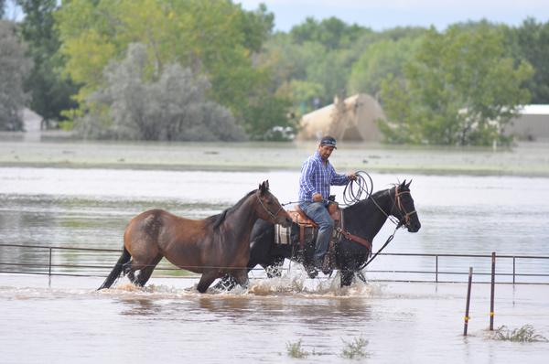
DIRECTIONS TO PLATTE RIVER FORT: Highway 34 is ONLY open from the east, (Kersey), OR, you can take CO Rd 49 to Highway 34 and take a left, (west) to county road 47 and turn right to PLATTE RIVER FORT.
From Denver area, take I-76 East to the “Kersey Road” about 1 mile east of Hudson; go north to hwy. 34; then left onto 34 about 1 mile to county road 47, turn right, you’ll see PLATTE RIVER FORT.
CLEAN UP CREWS
Volunteers needed for clean up at PLATTE RIVER FORT, FARM and MEYER PROPERTIES:
  - Friday, September 20, 2013

  - Saturday, September 21, 2013

  - Sunday, September 22, 2013

Hats off to our friends in Colorado our thoughts and prayers are with you!

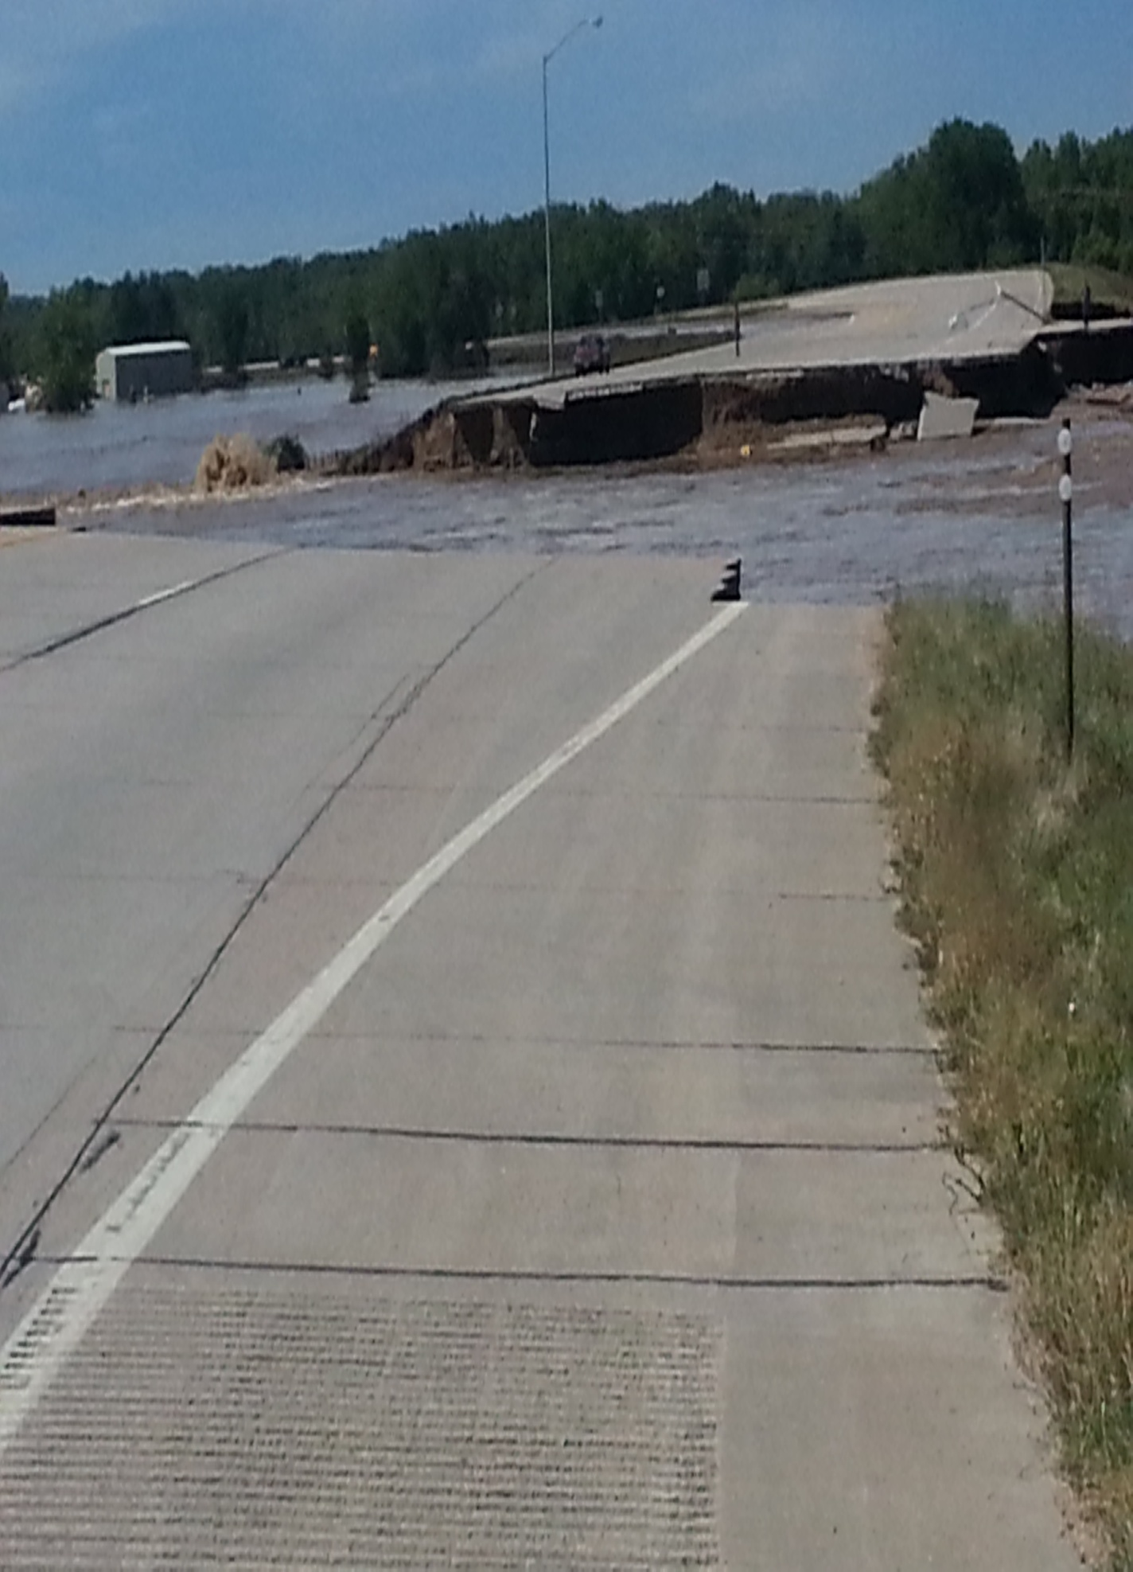
Please sign up for which day or days you will be able to volunteer.
FOR THEIR SAFETY: PLEASE KEEP YOUR PETS AT HOME.
CHILDREN ARE WELCOME, BUT FOR THEIR SAFETY, WILL NOT BE ALLOWED IN CLEANUP AREAS BUT CAN STAY IN FORT OR BARN AREA.

- CLEAN UP VOLUNTEERS
- WE WILL PROVIDE RUBBER GLOVES.
NOTE: According to the Center for Disease Control (link to the CDC website on Weld County Website) you SHOULD ALSO have:
  - RUBBER BOOTS OR OTHER WATERTIGHT BOOTS;
  - EYE PROTECTION (goggles);
  - ANY OTHER PROTECTIVE CLOTHING YOU HAVE FOR CLEAN UP PURPOSES
CDC ALSO STATES “WASH ALL CLOTHES WORN DURING THE CLEANUP IN HOT WATER AND DETERGENT. THESE CLOTHES SHOULD BE WASHED SEPARATELY...”

- Please RSVP for CLEAN UP
- For coordination purposes we will need to know the numbers and the days to expect the volunteers.

- Please send ALL RSVPs to ddepriest@carletongotlinlaw.com or call Dawn
- at303.825.1125 or 303.513.0960. You can leave a message at either number.

